Age Verification Steps
- Log into usatf.sport80.com
- Click on the Respective Member box

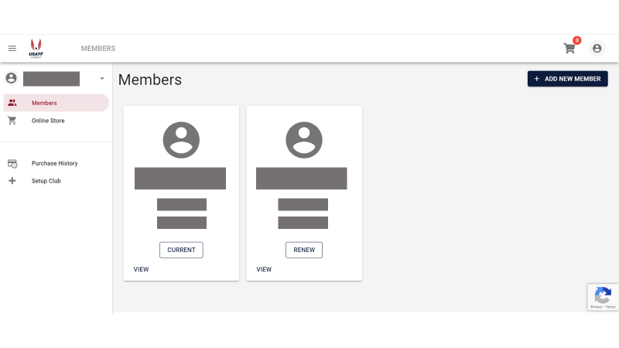
- Click on athlete verifications
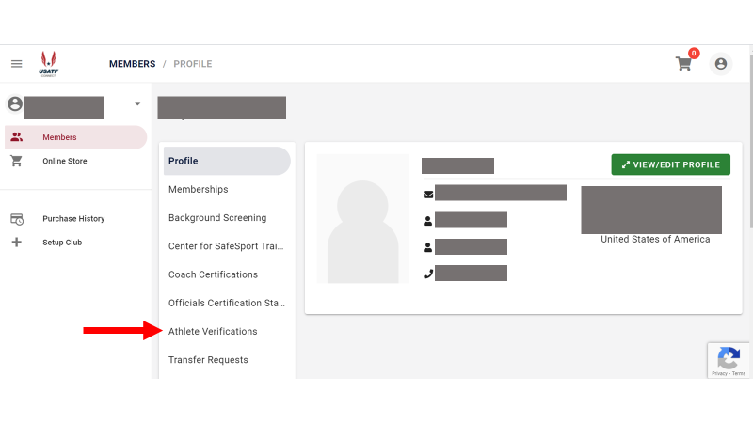

- Click on Add Athlete Verification
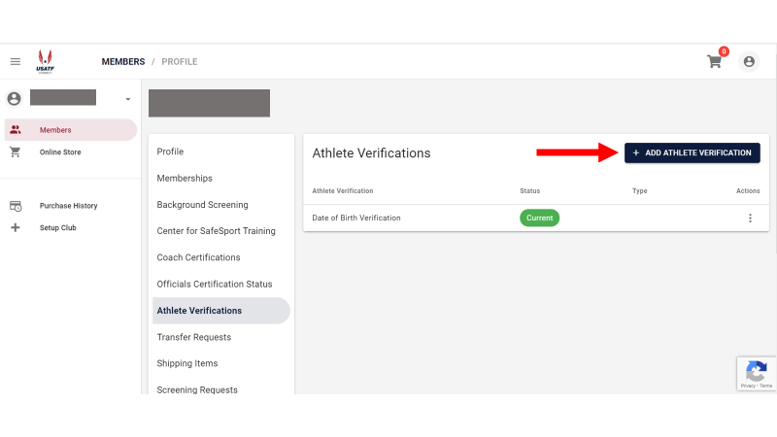

Transfer Requests
- Go to usatf.sport80.com
- Click on respective member box
- Click on Transfer Request
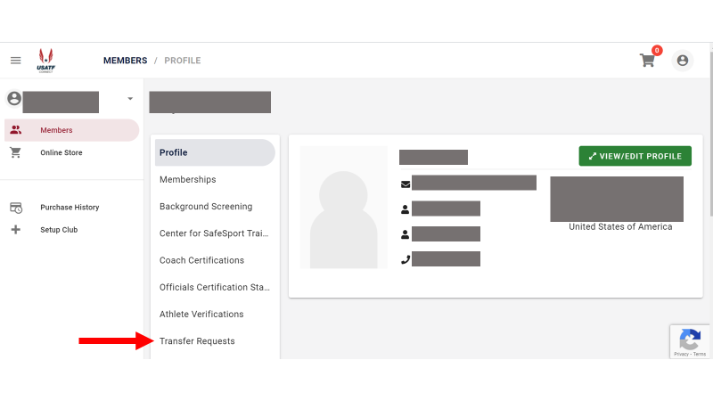

- Add Transfer Request
